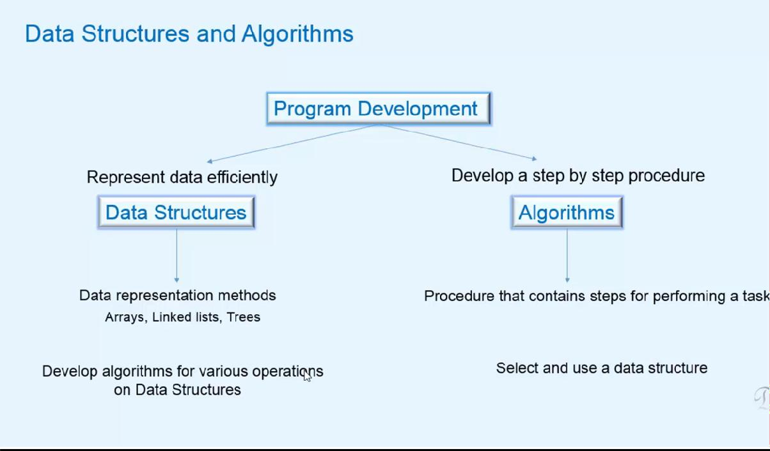

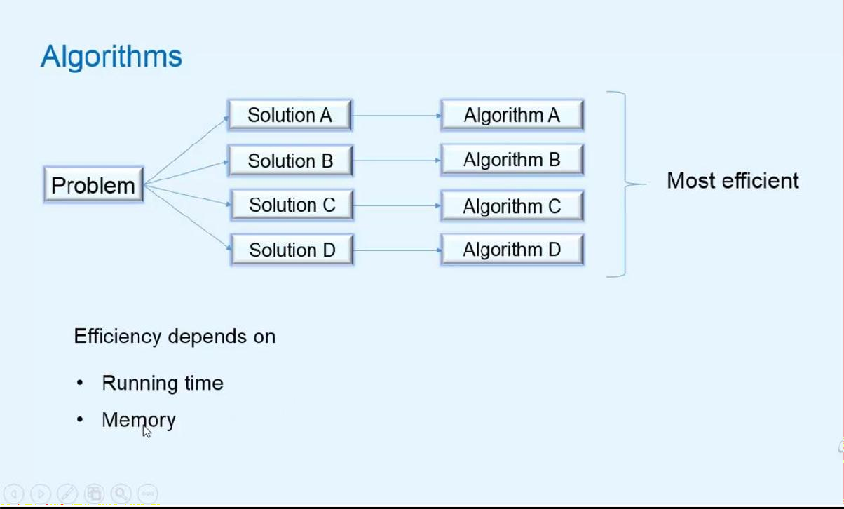

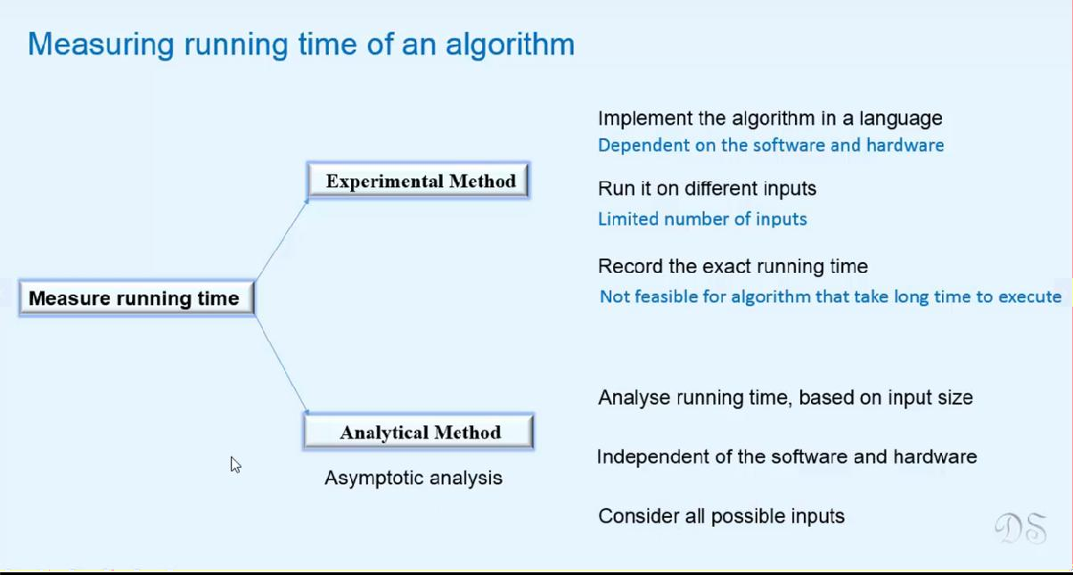

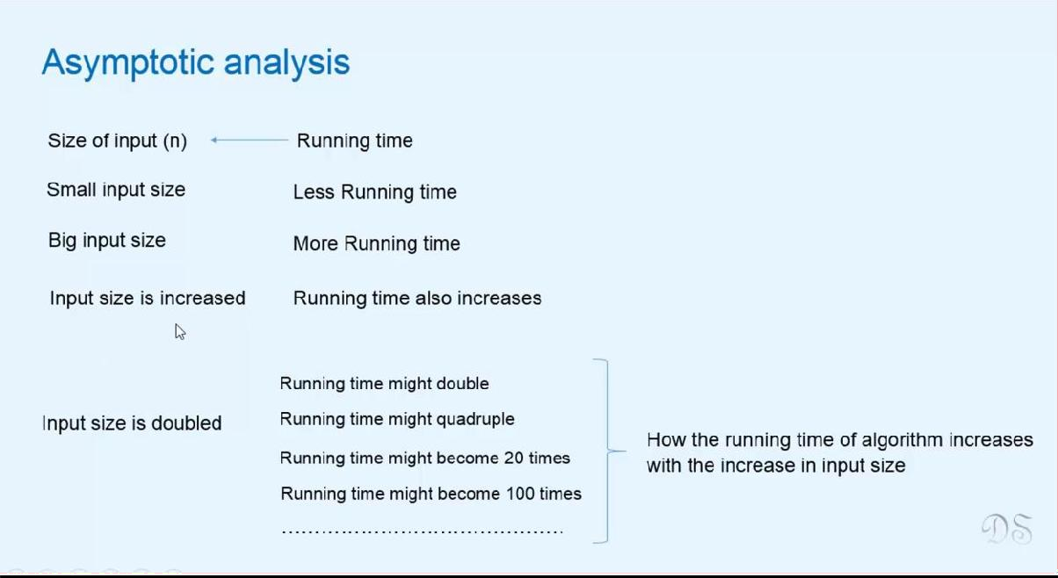

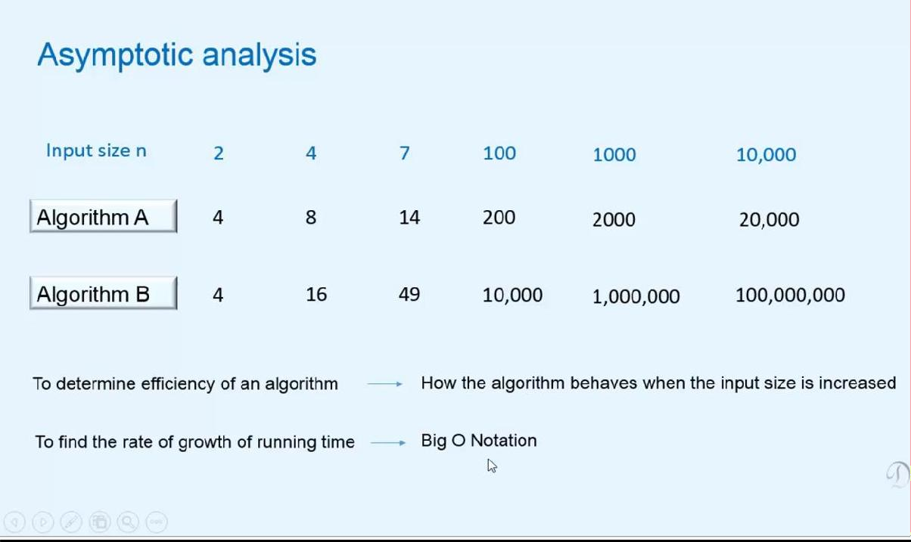

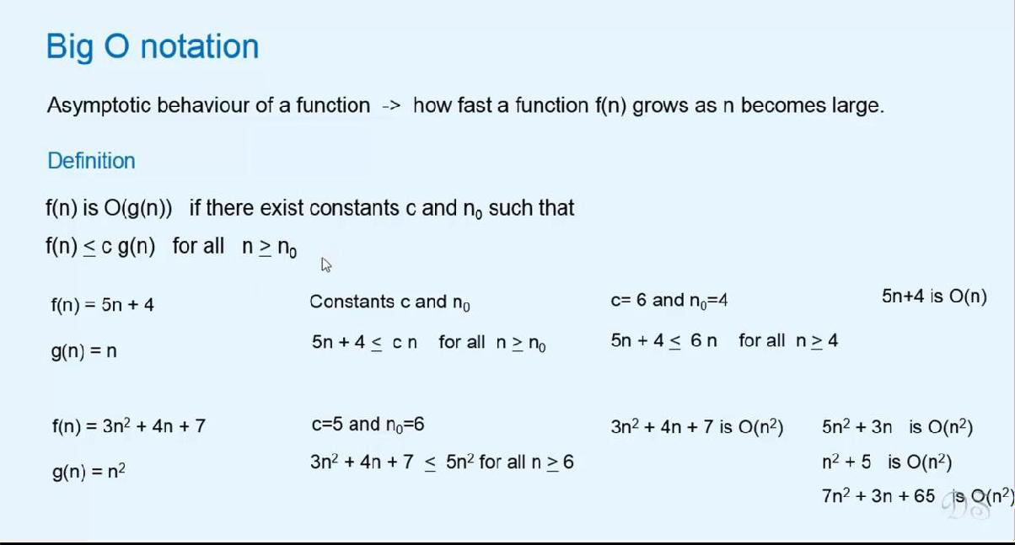

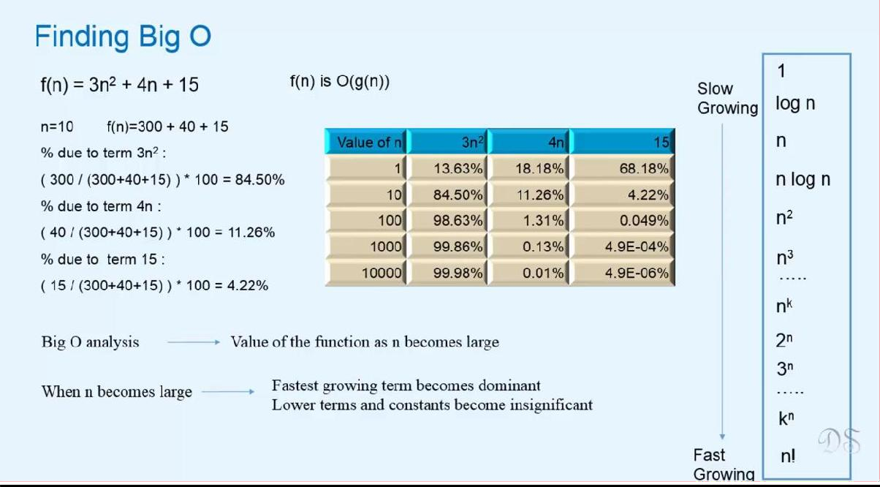

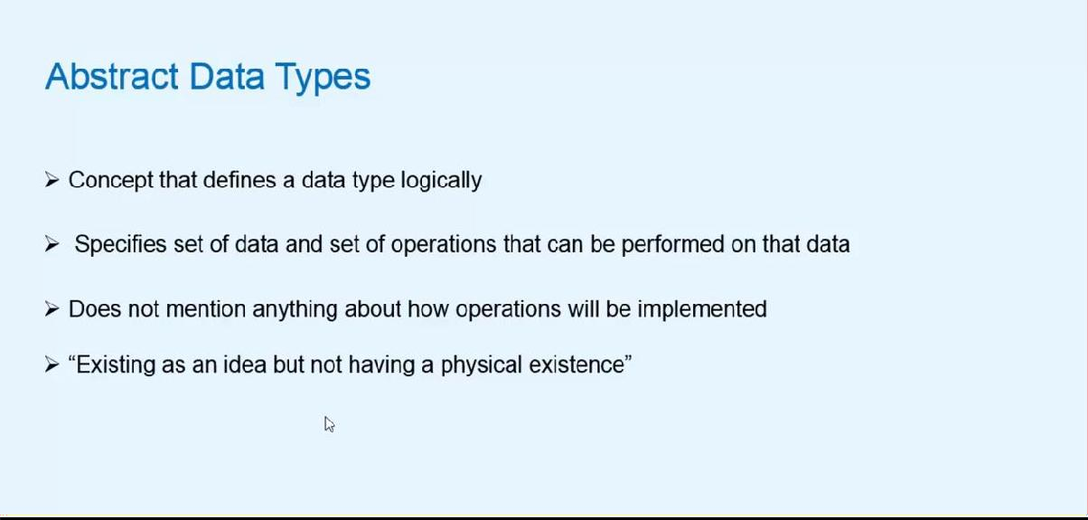

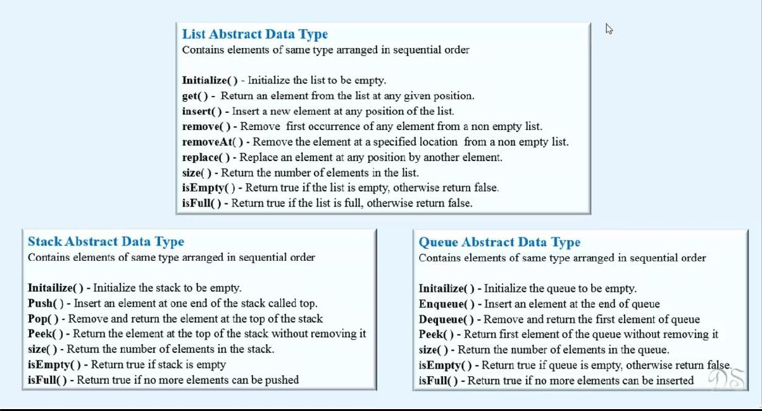

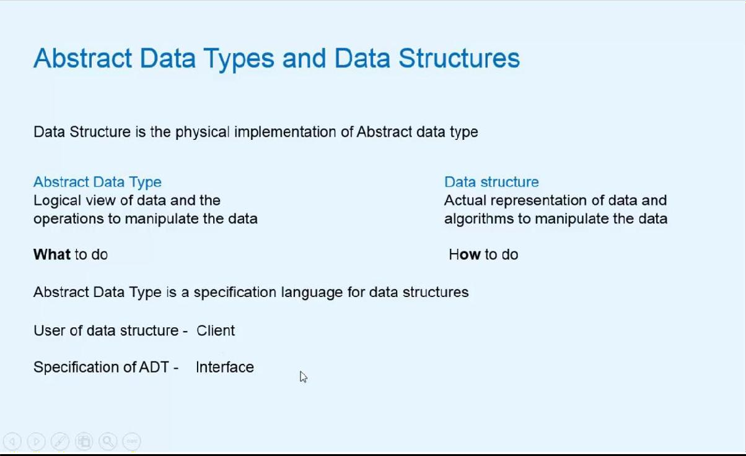

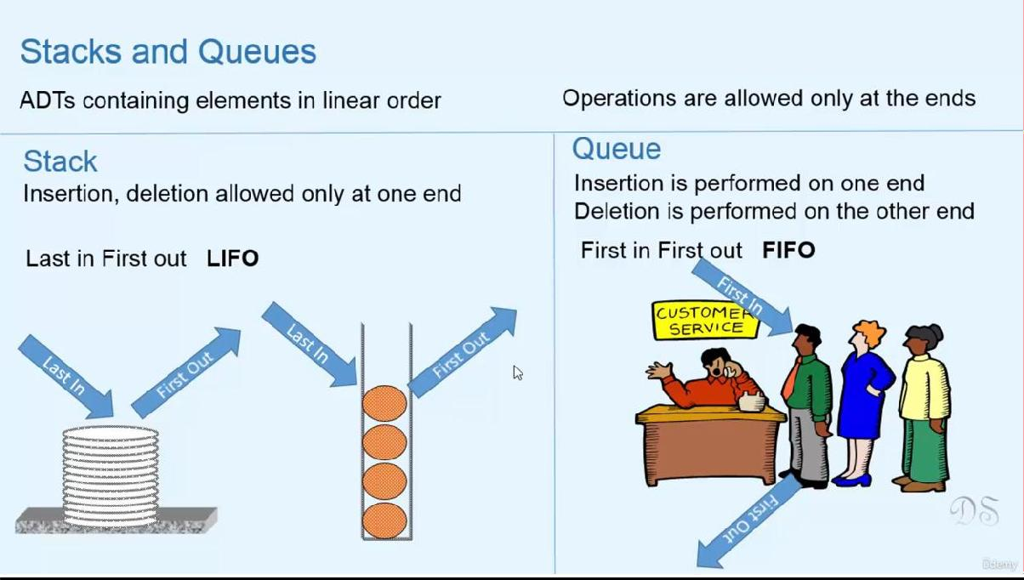

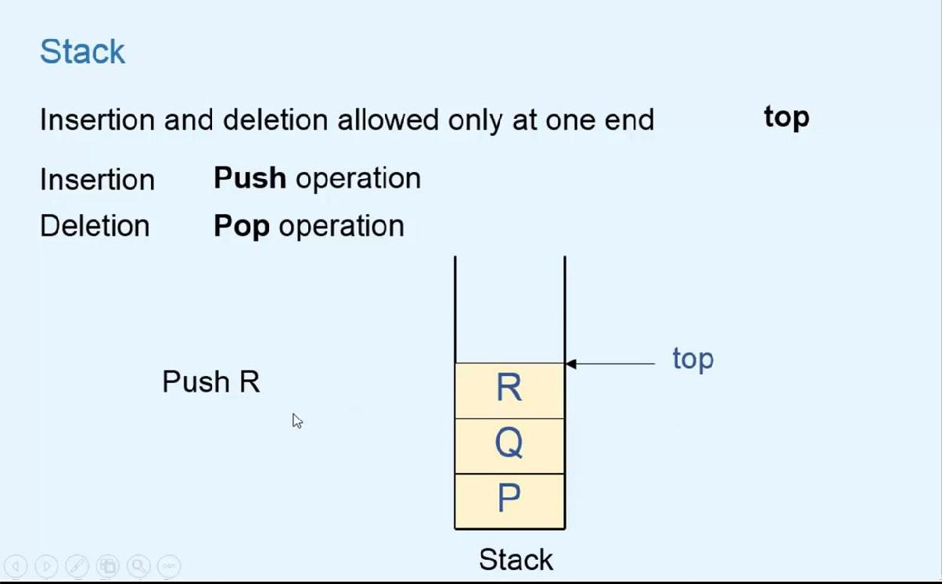

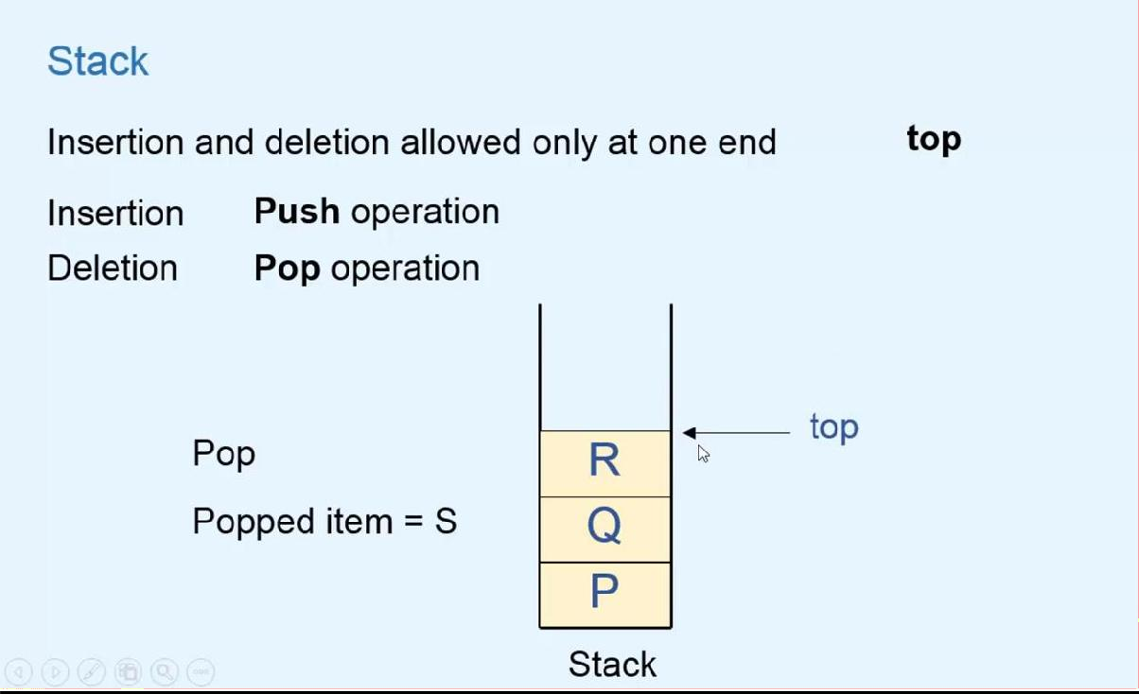

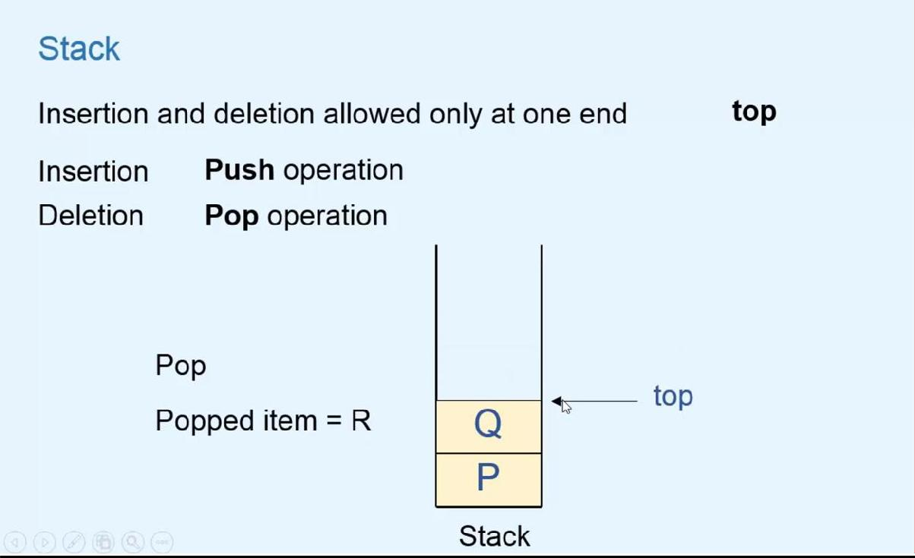

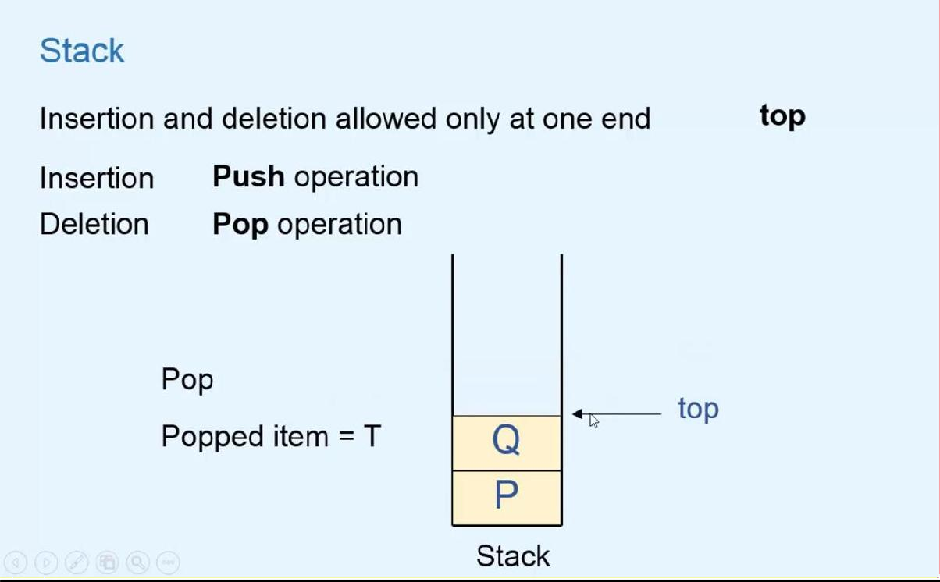

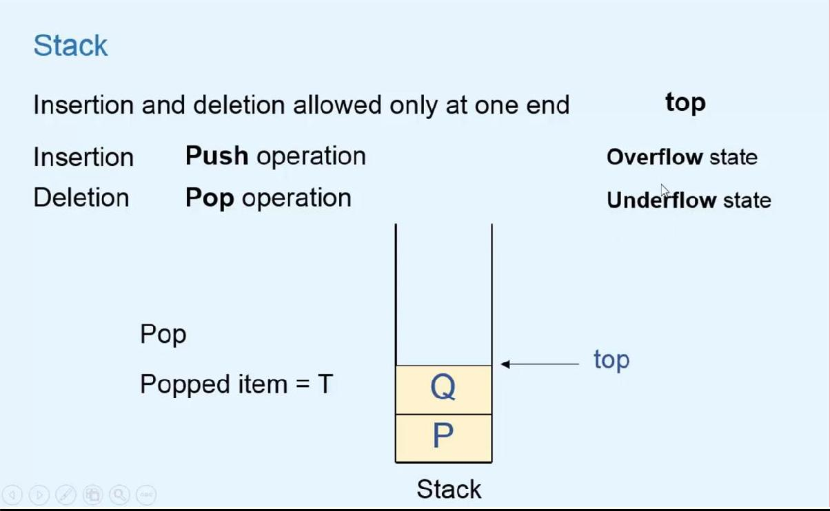

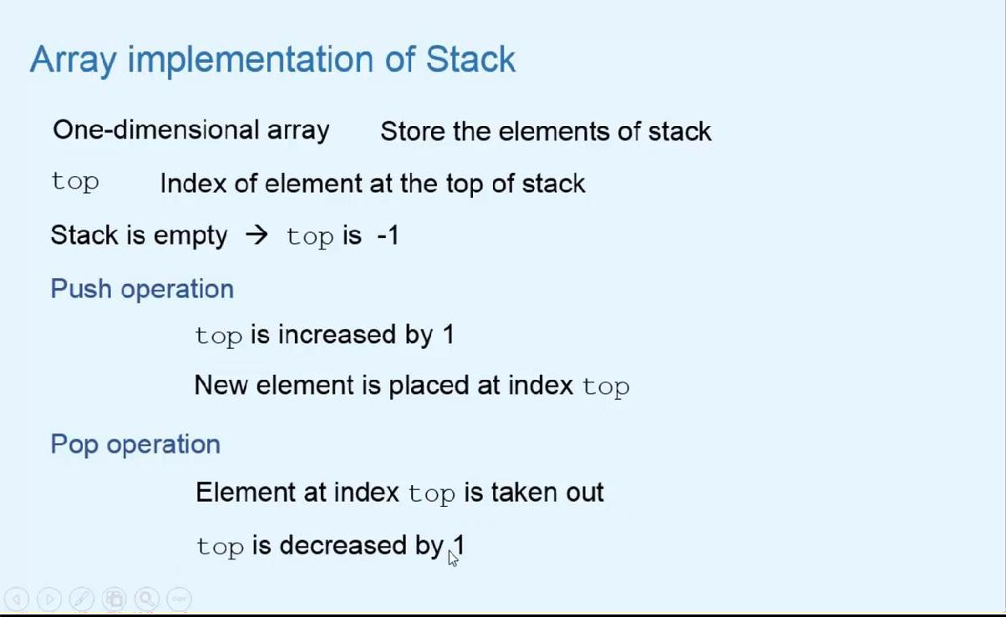

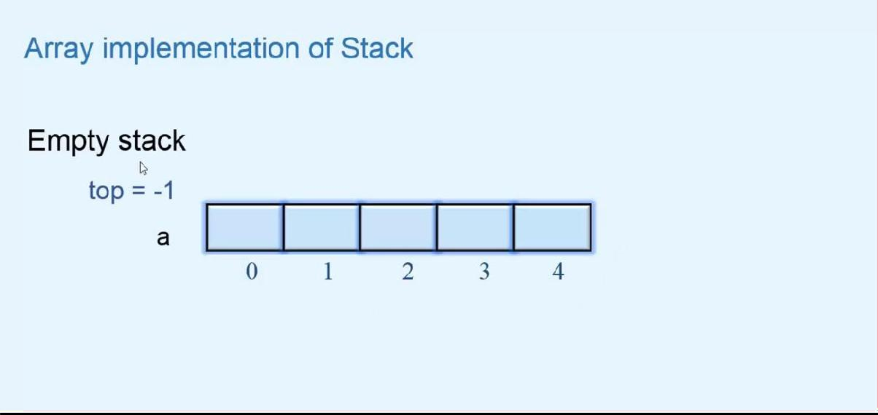

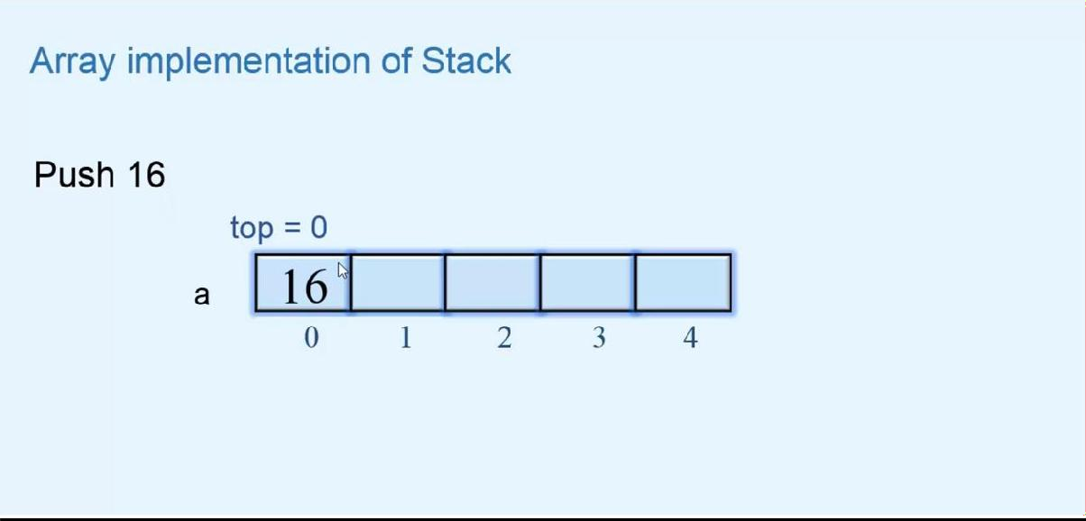

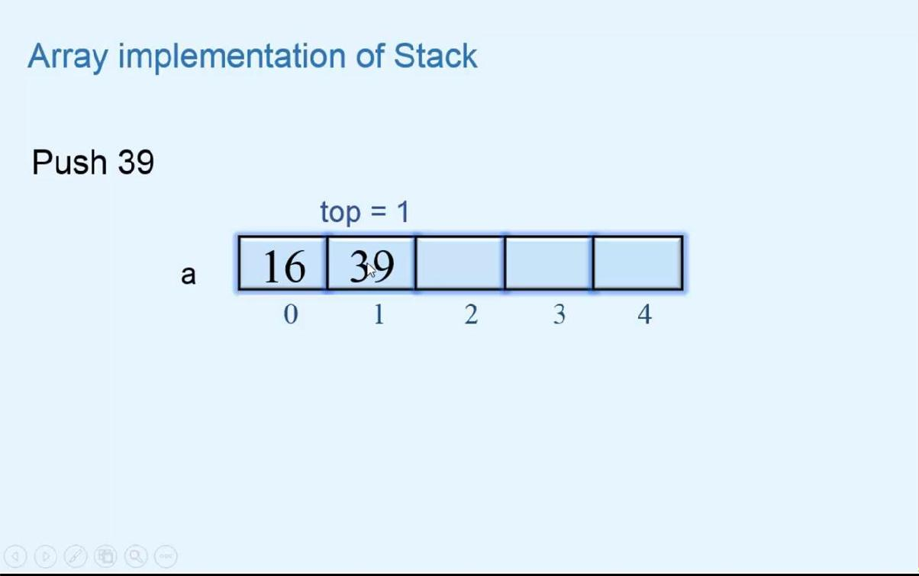

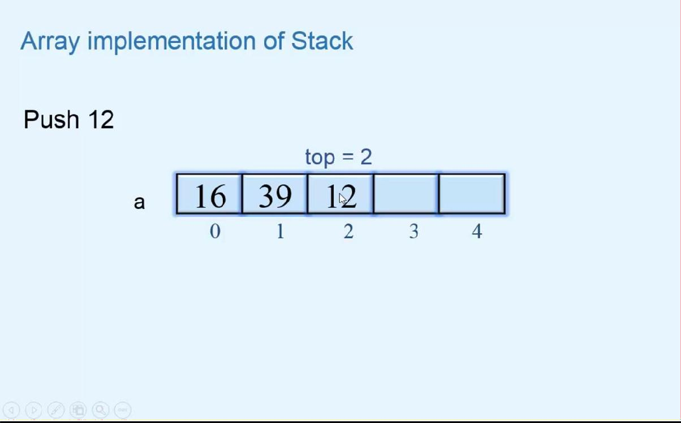

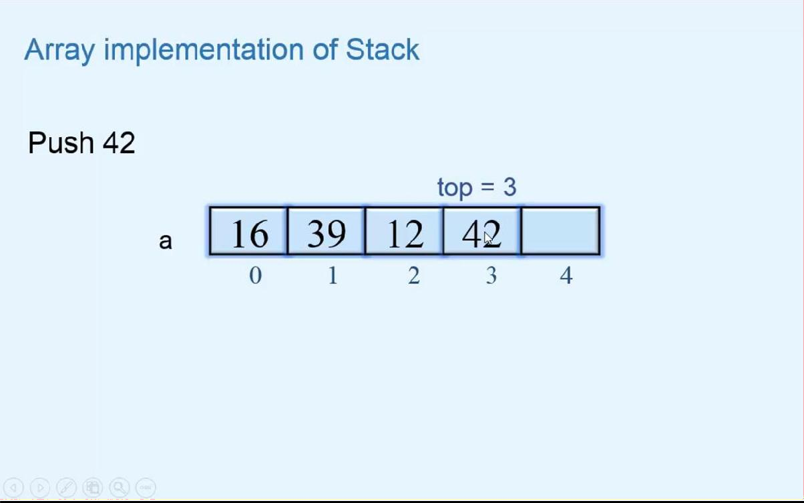

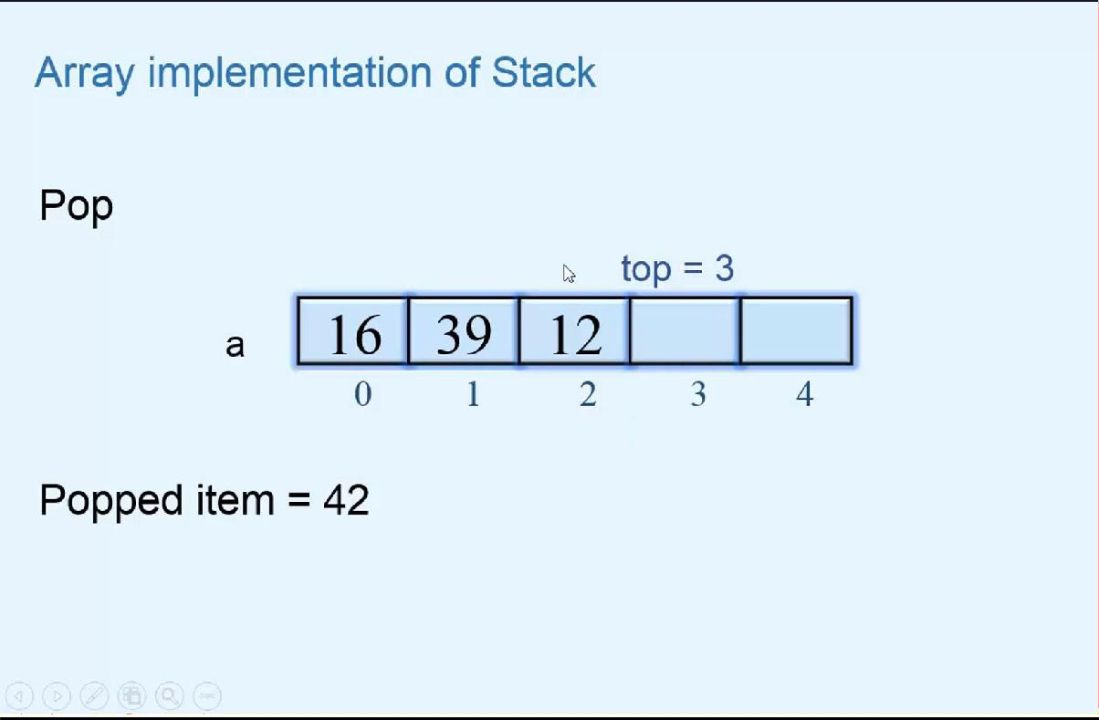

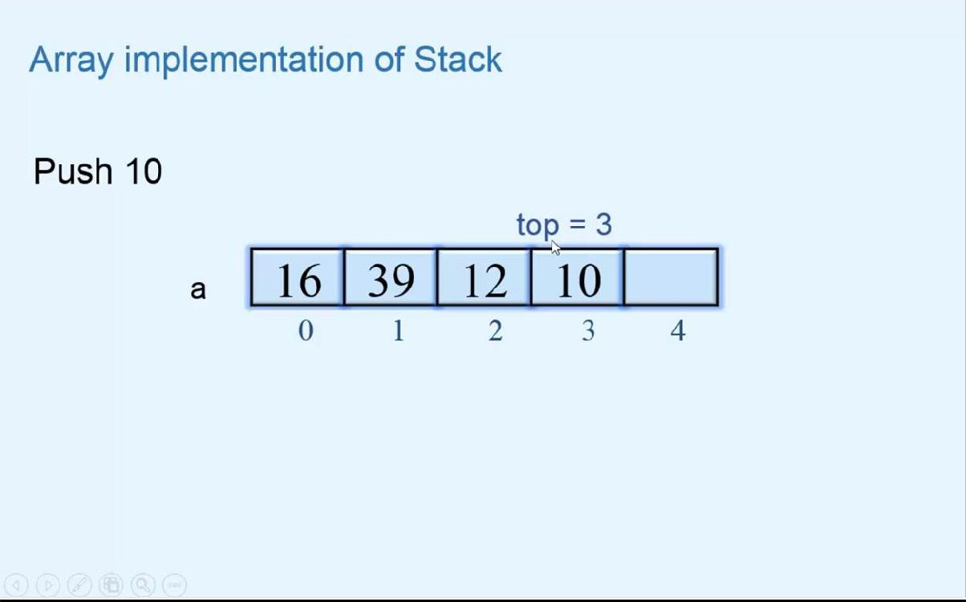

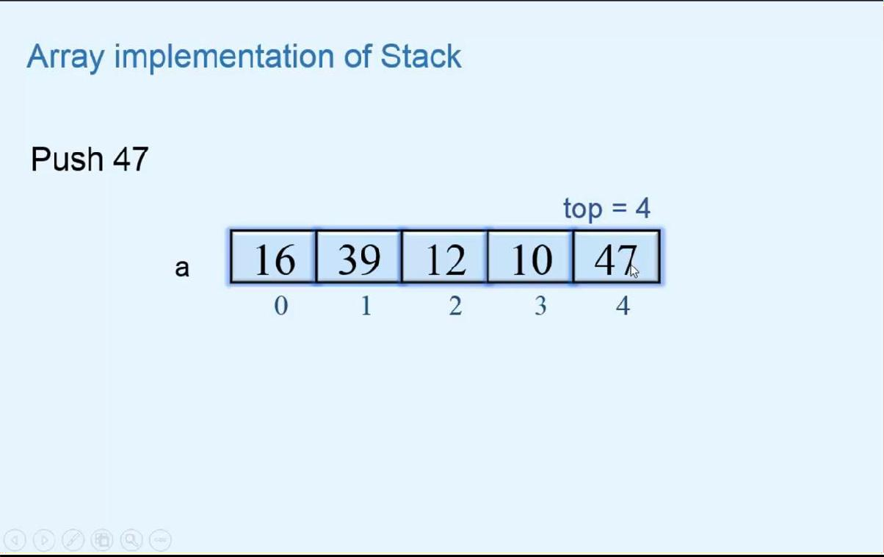

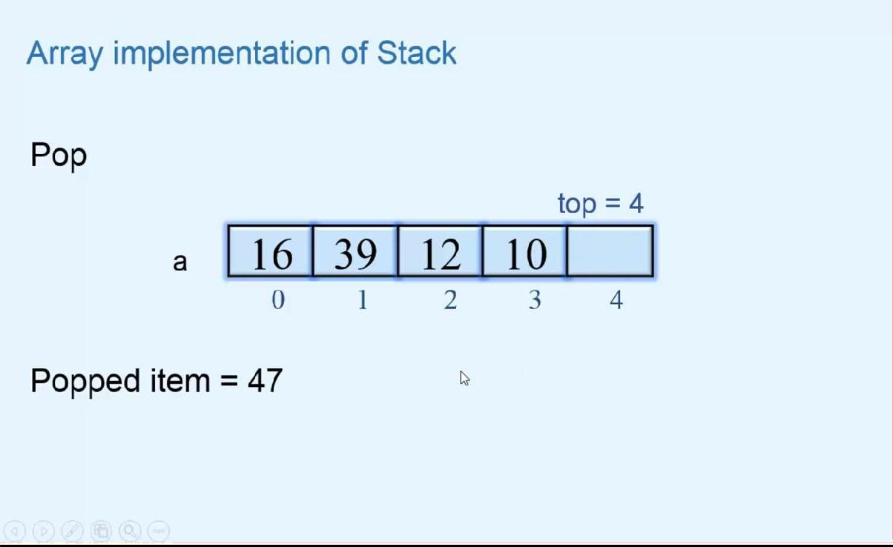

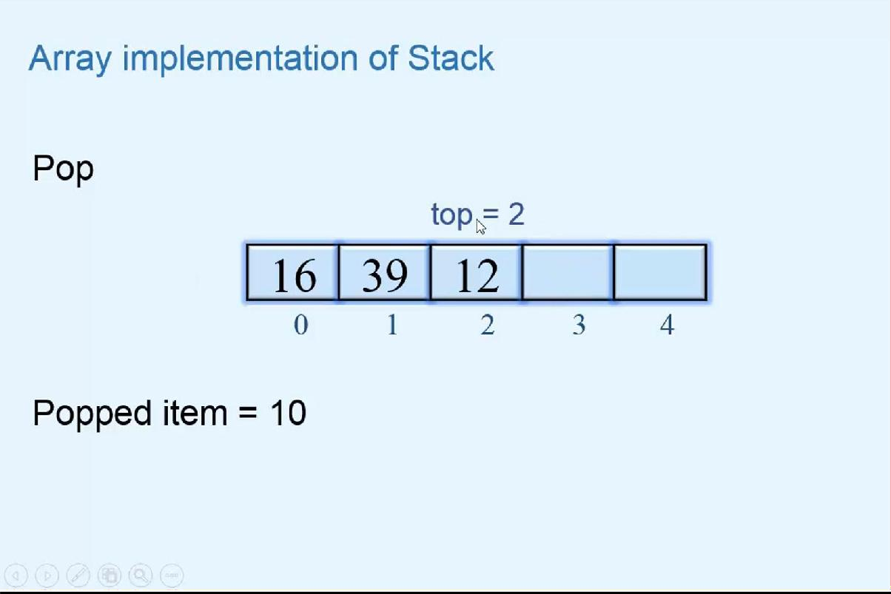

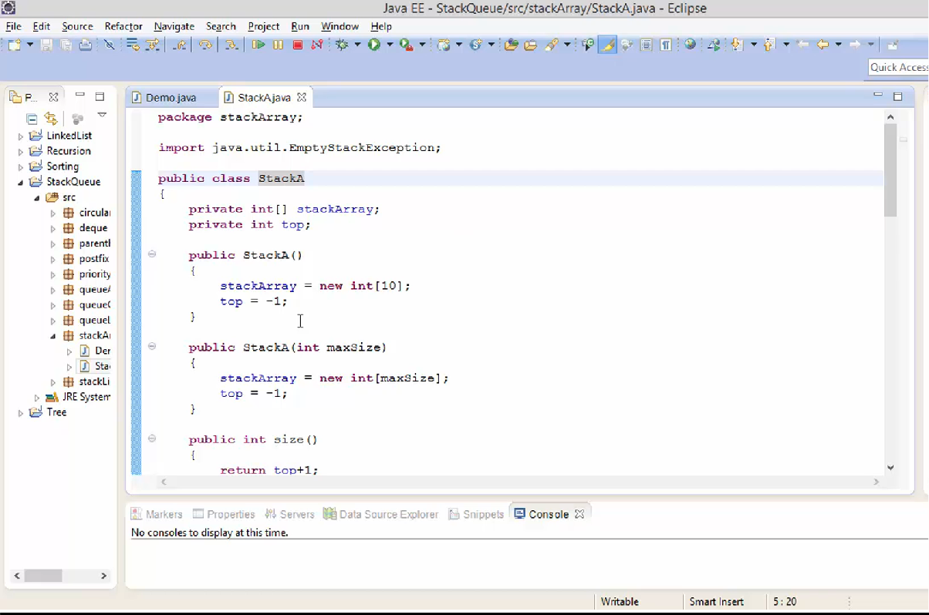

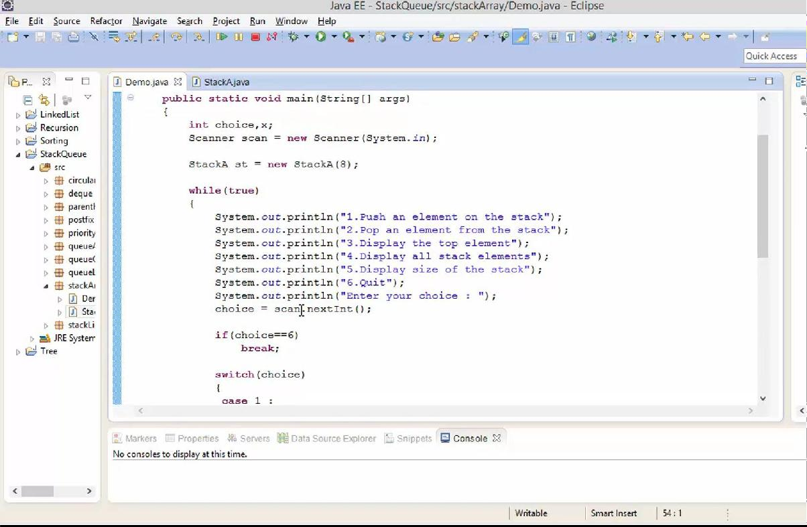

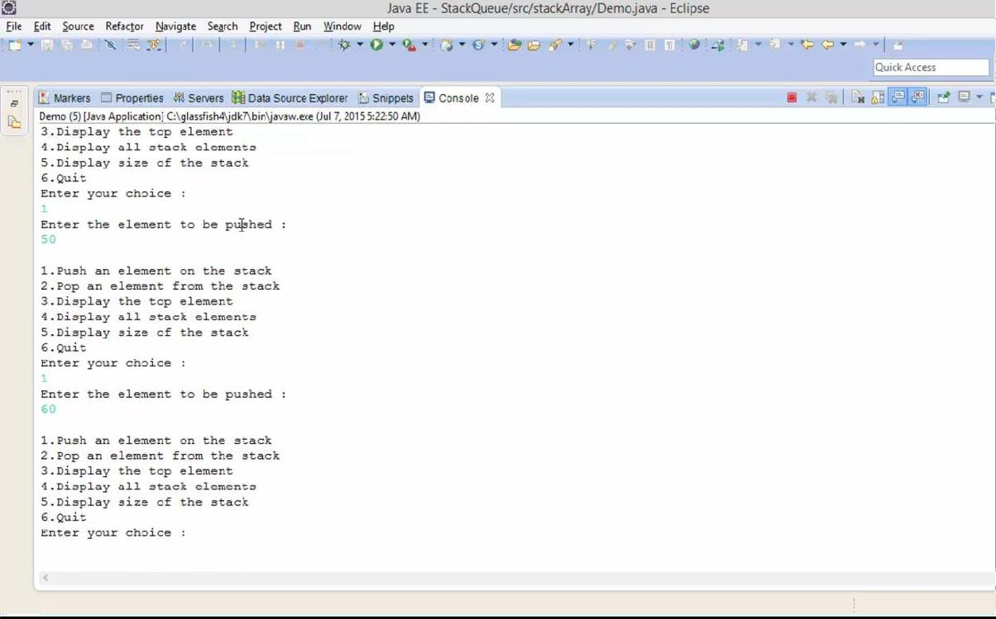

# QUEUE

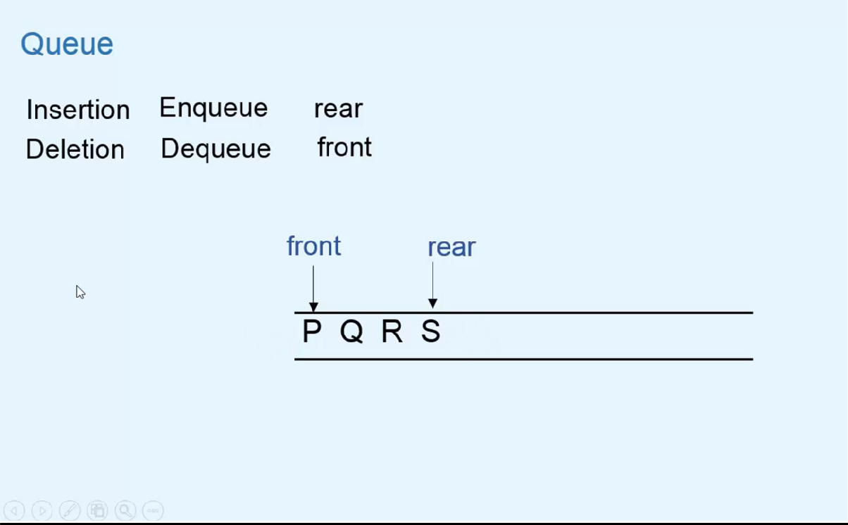

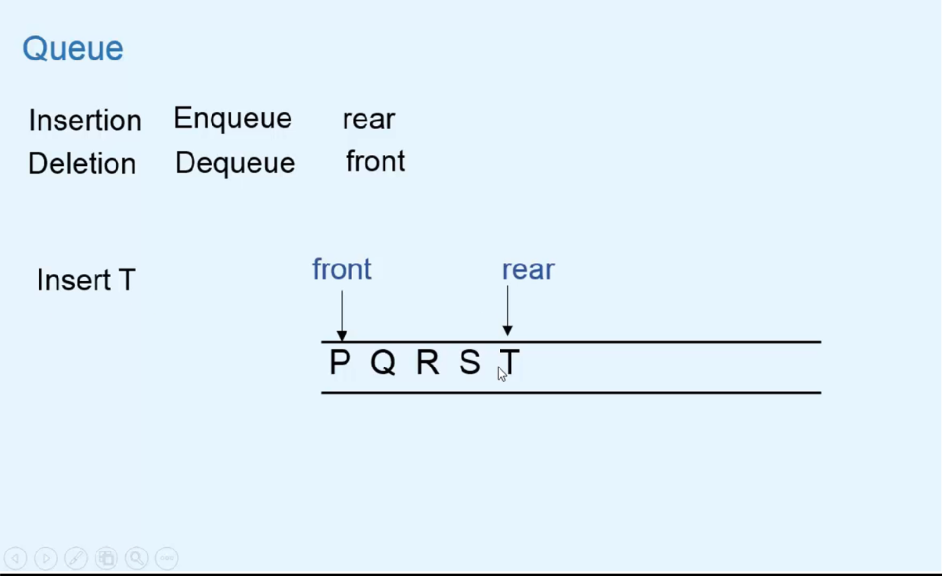

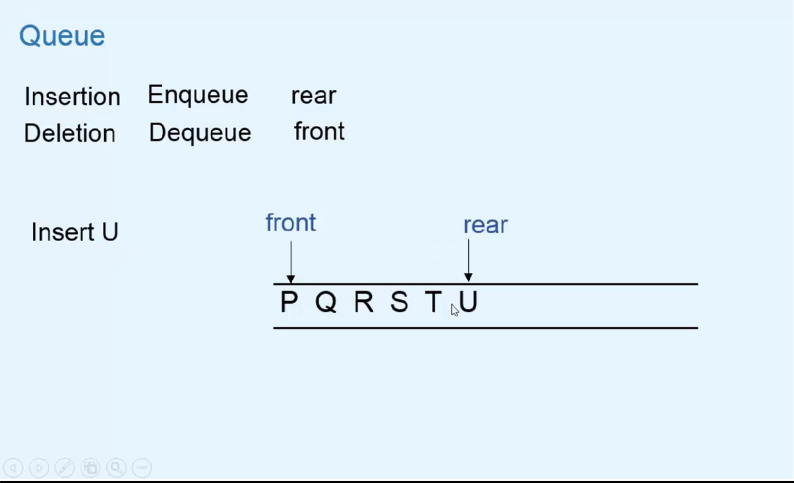

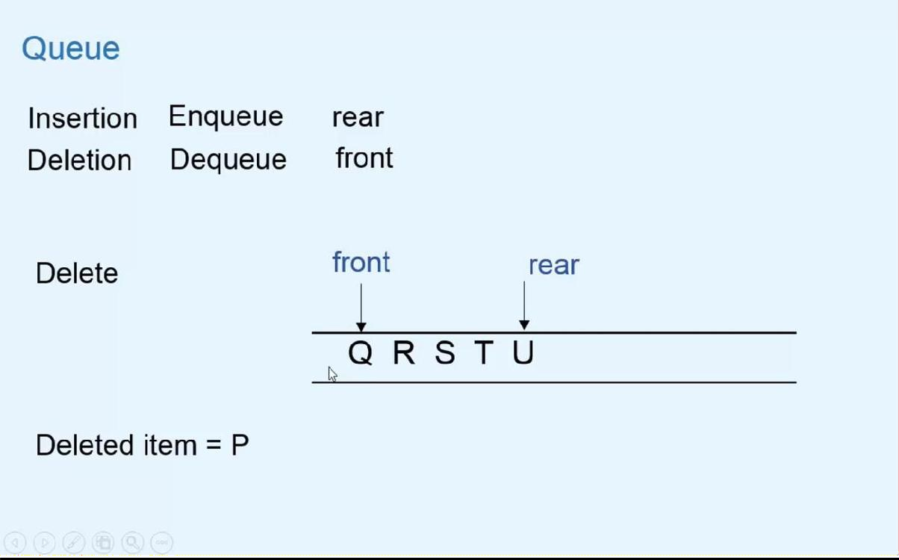

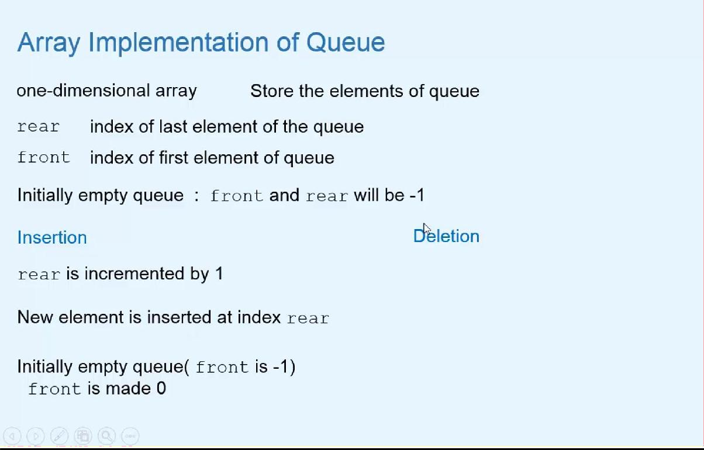

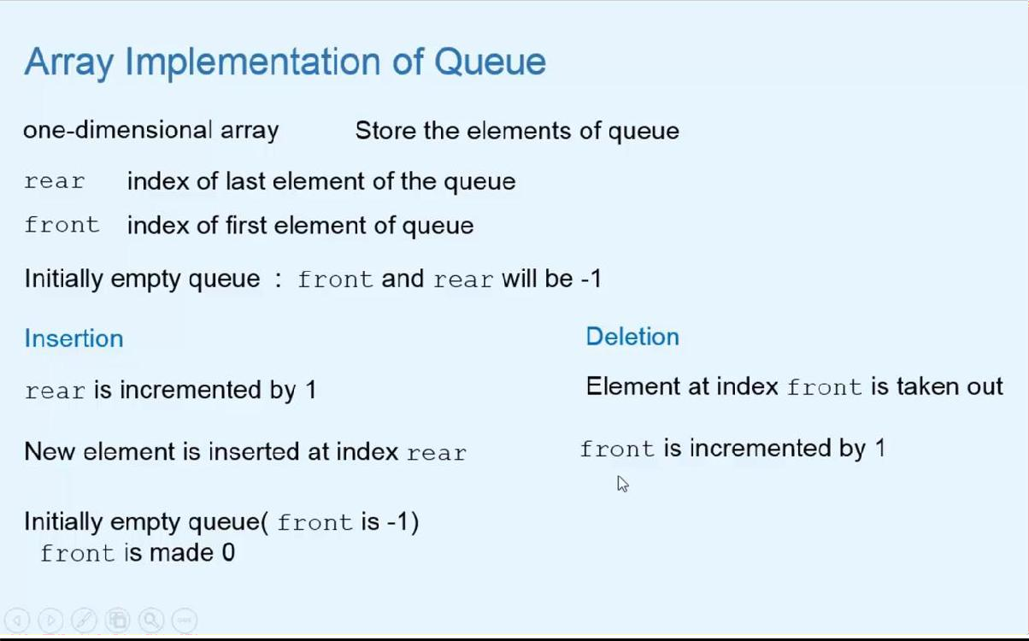

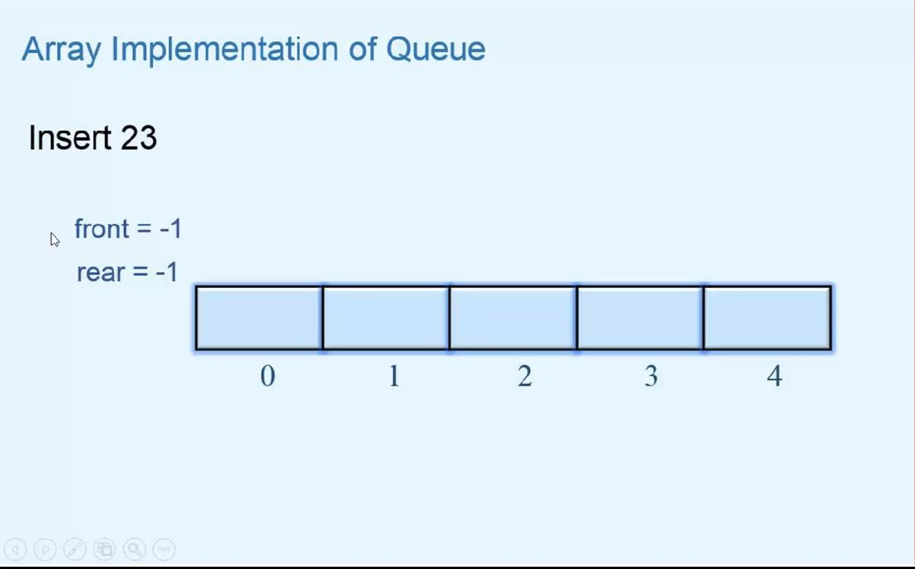

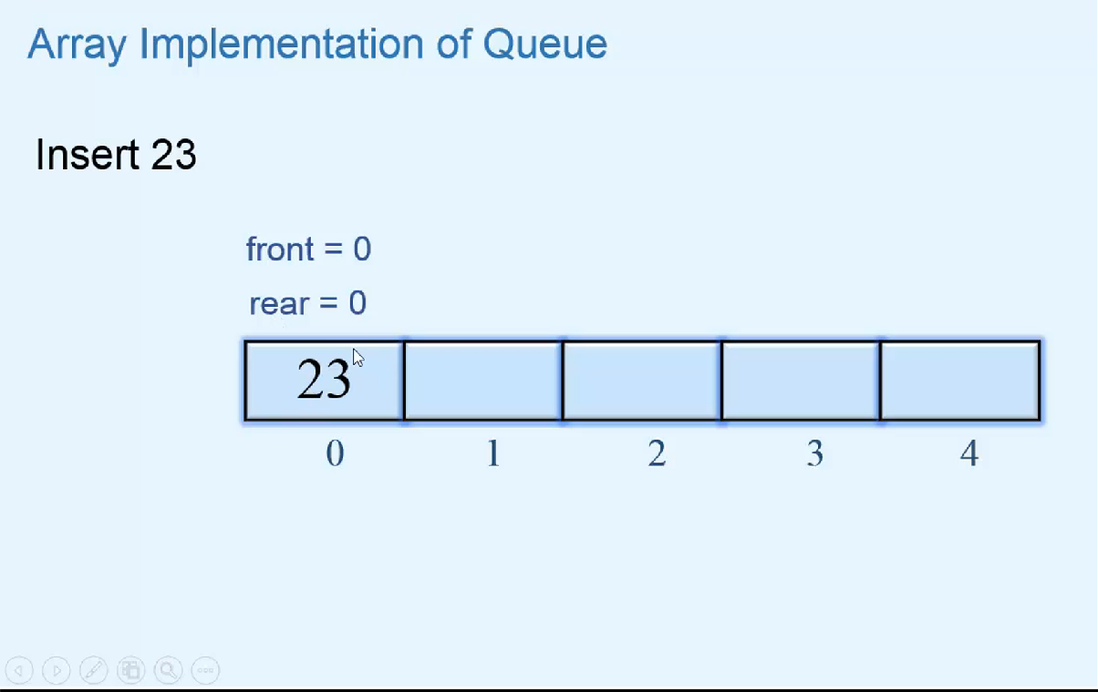

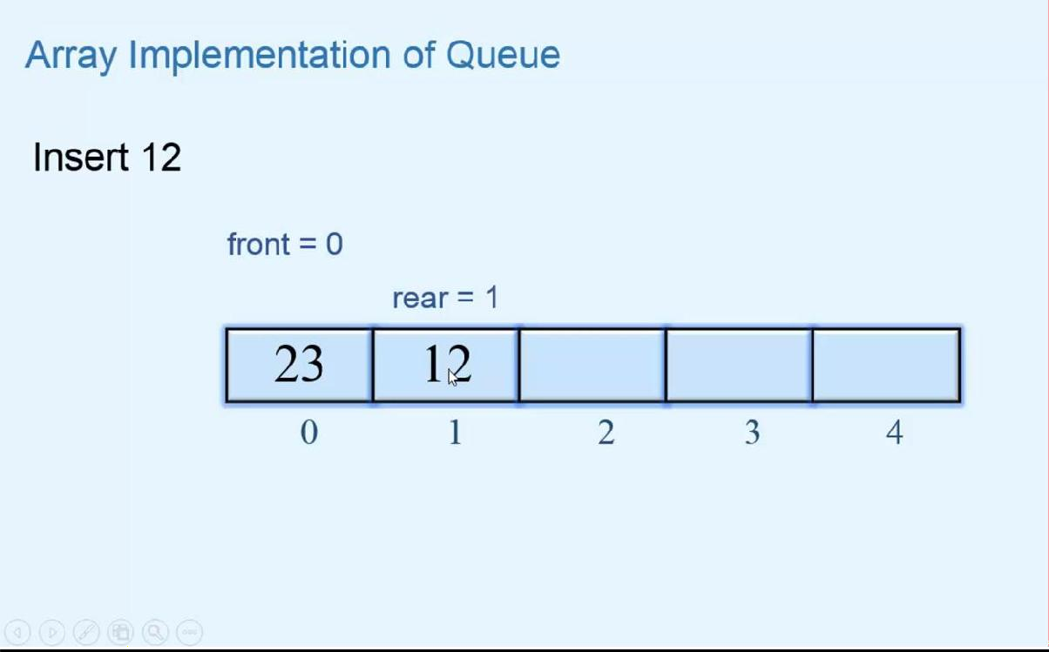

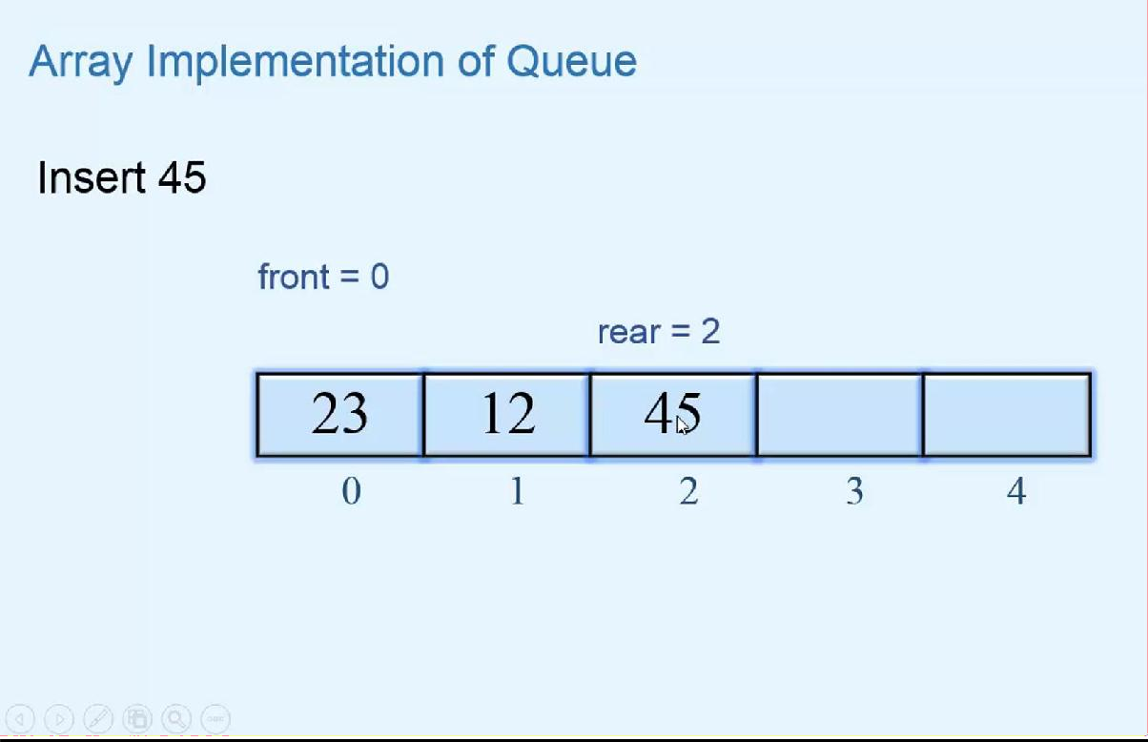

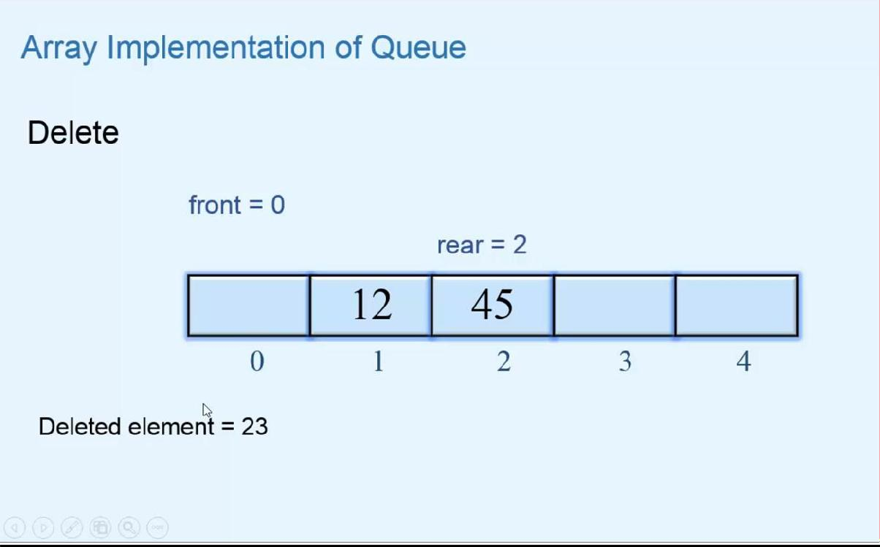

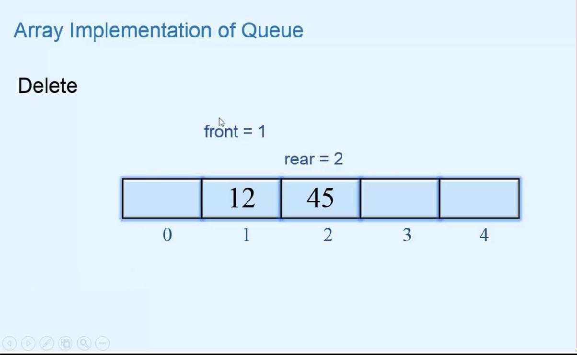

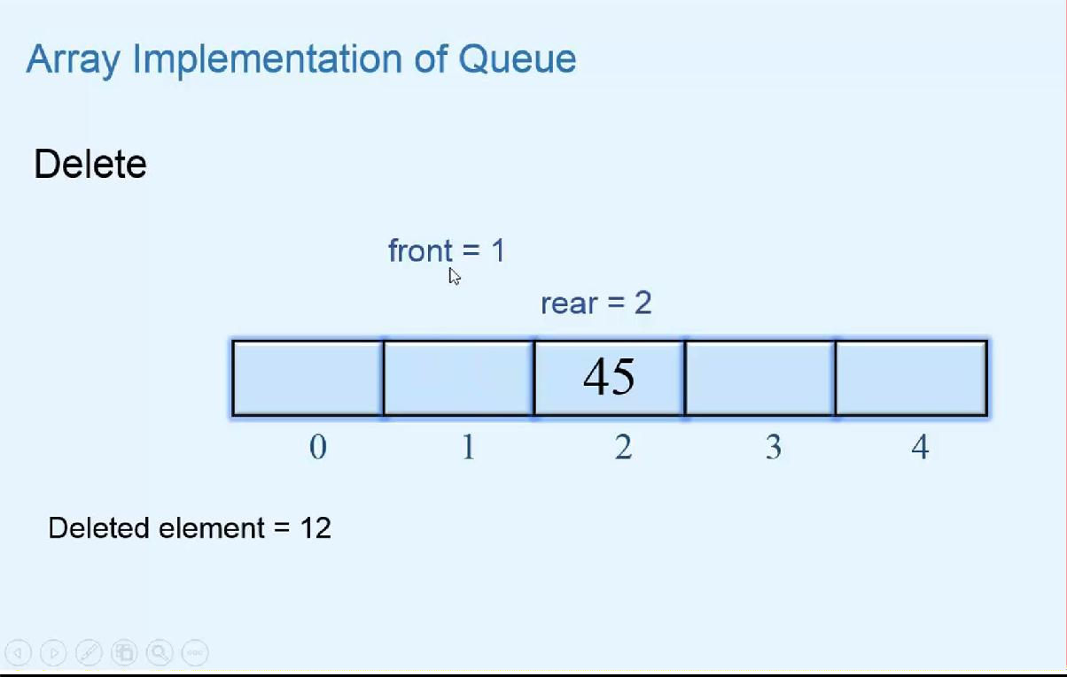

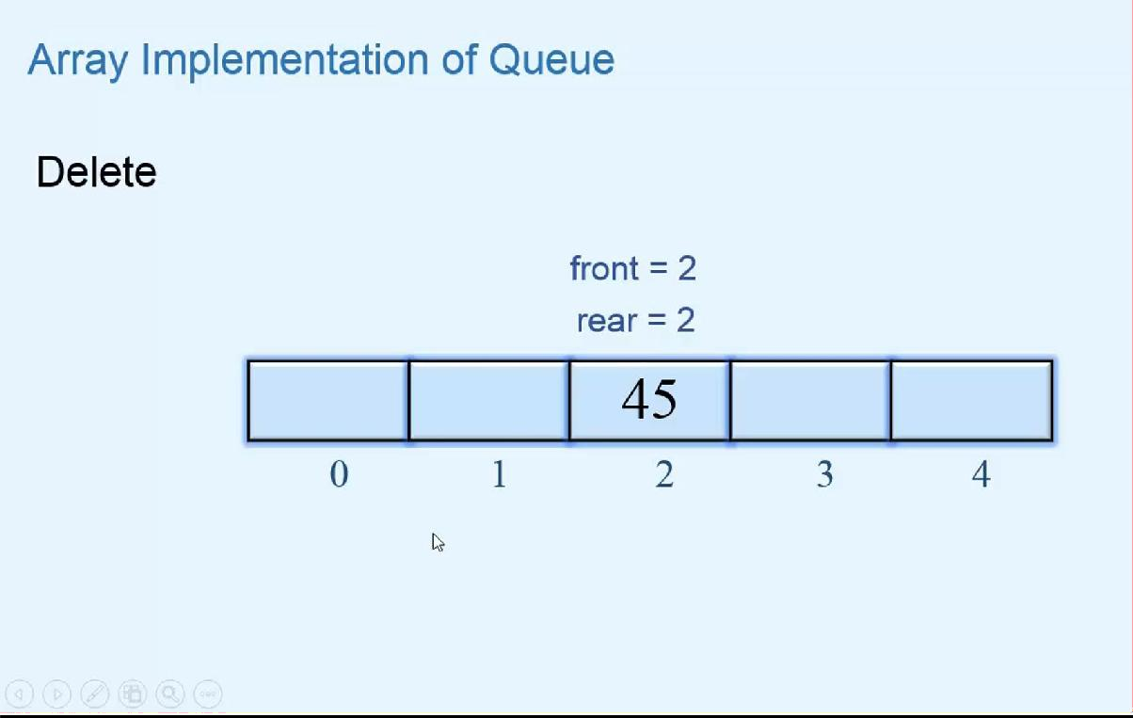

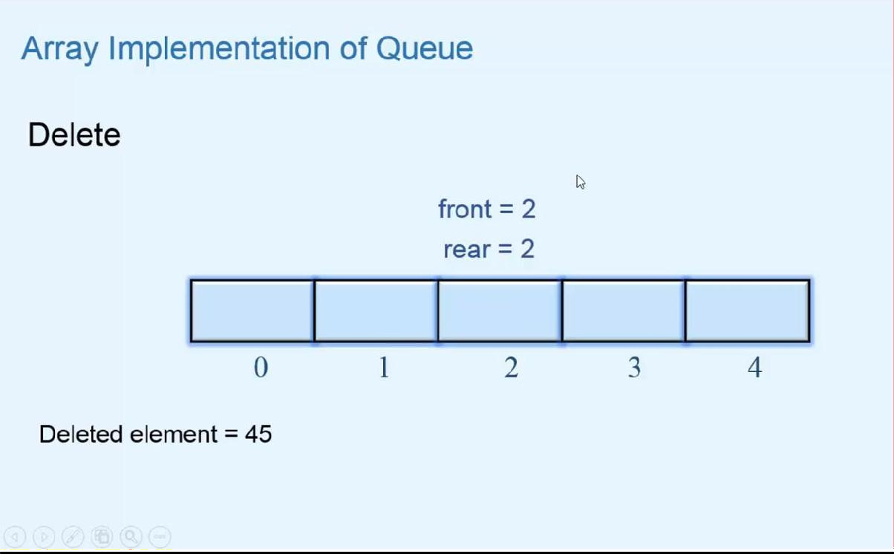

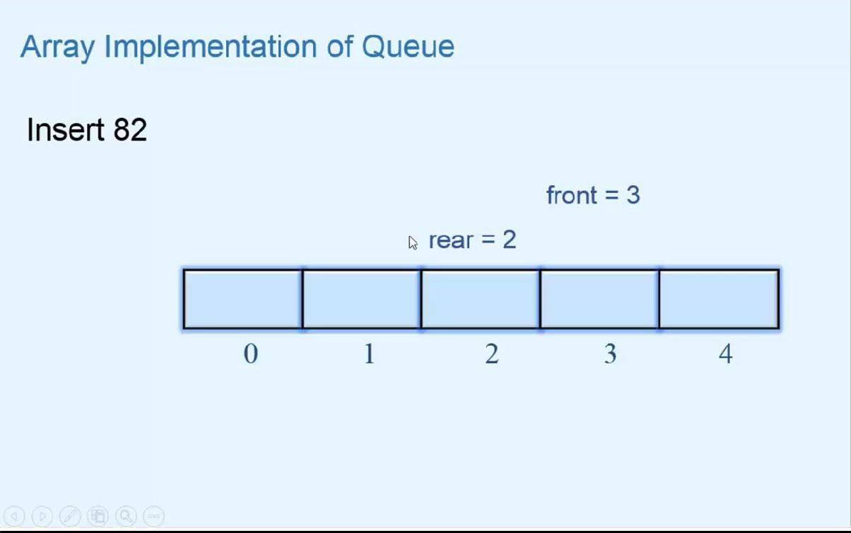

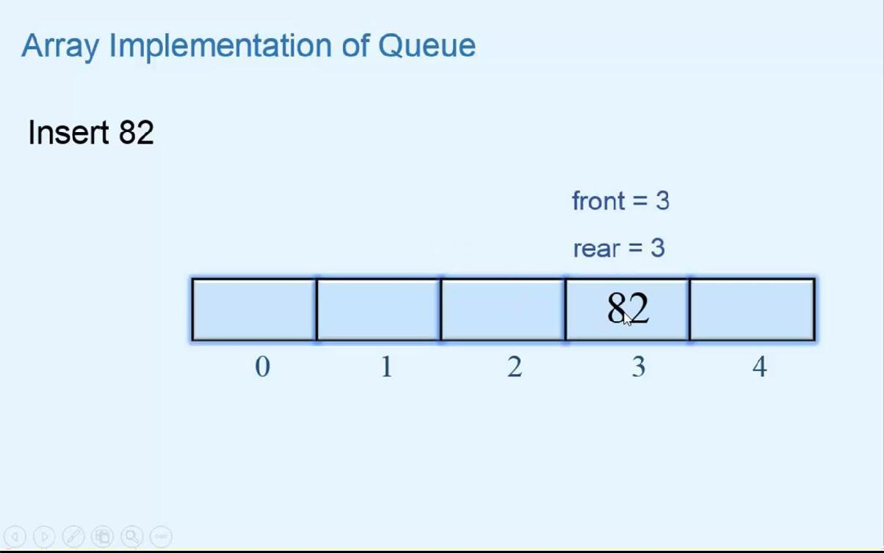

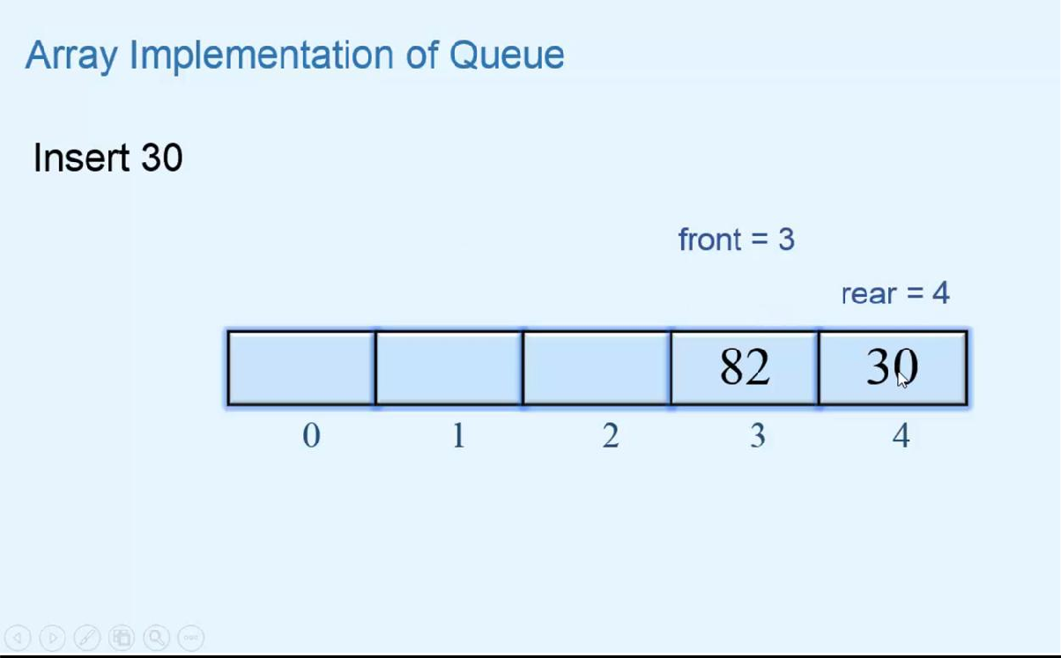

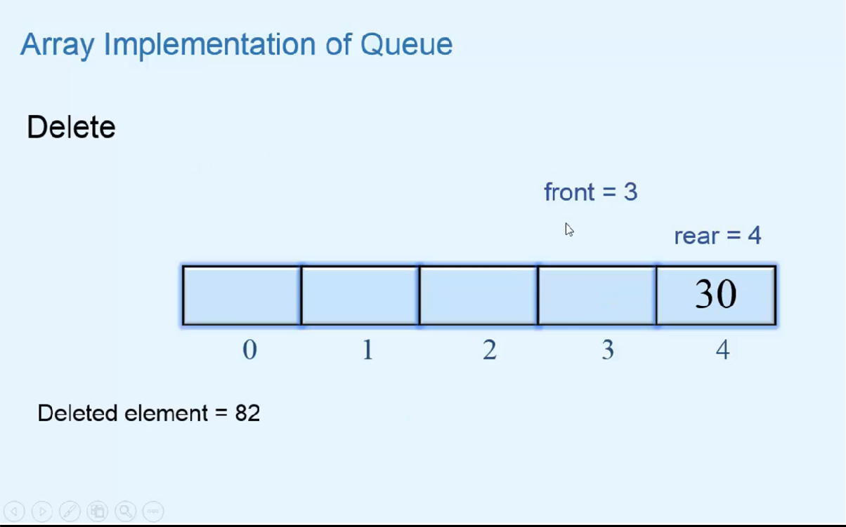

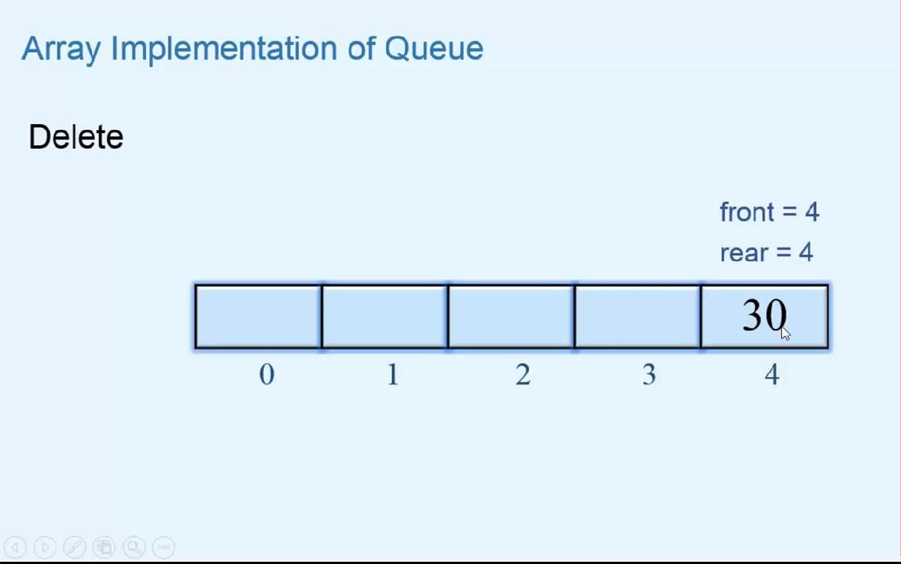

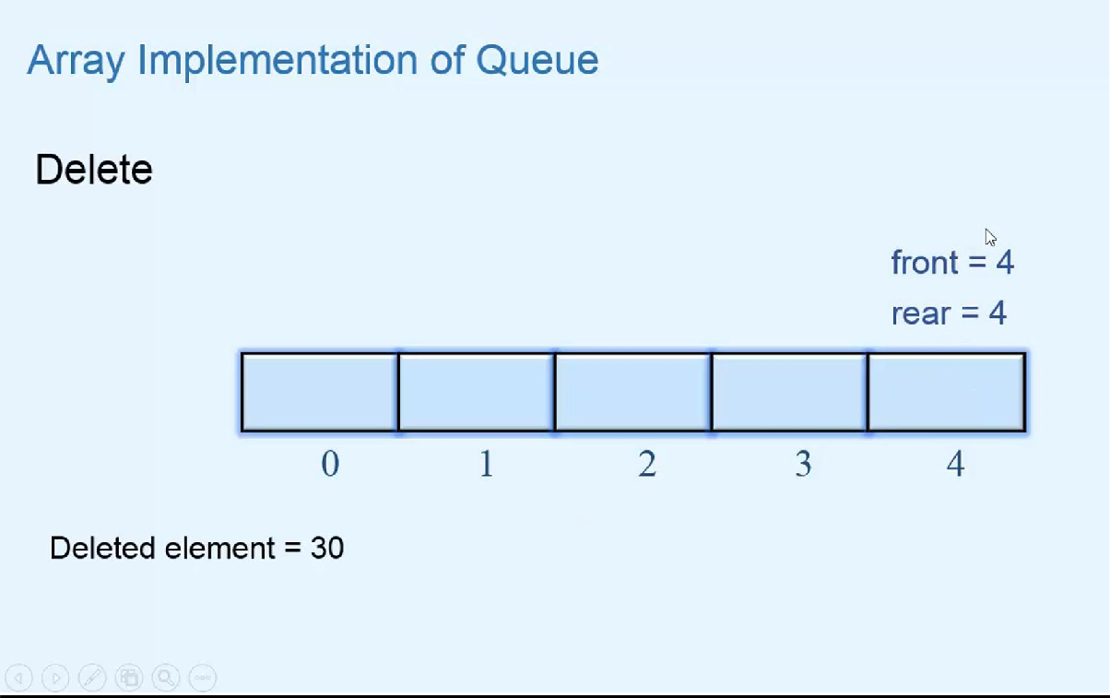

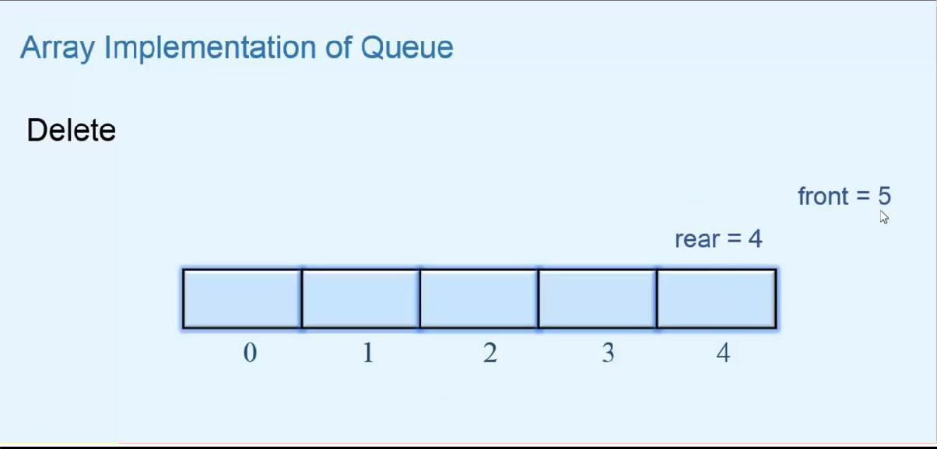

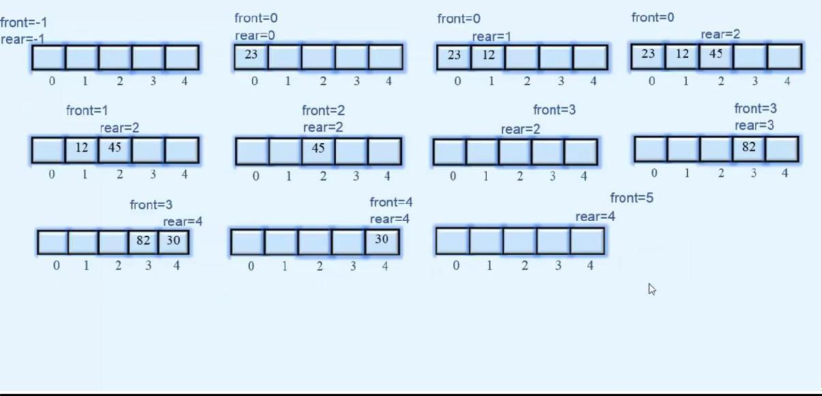

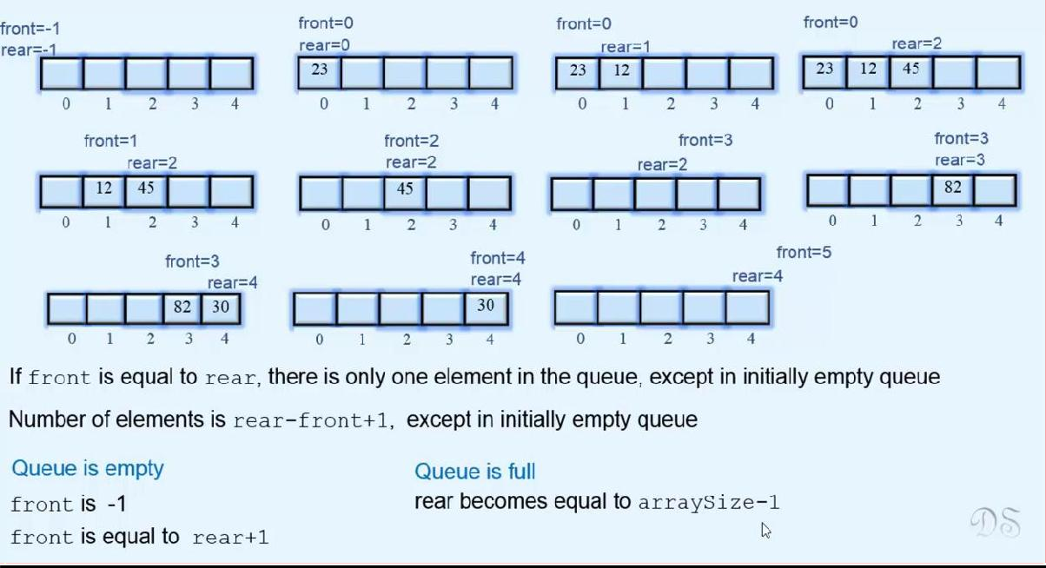

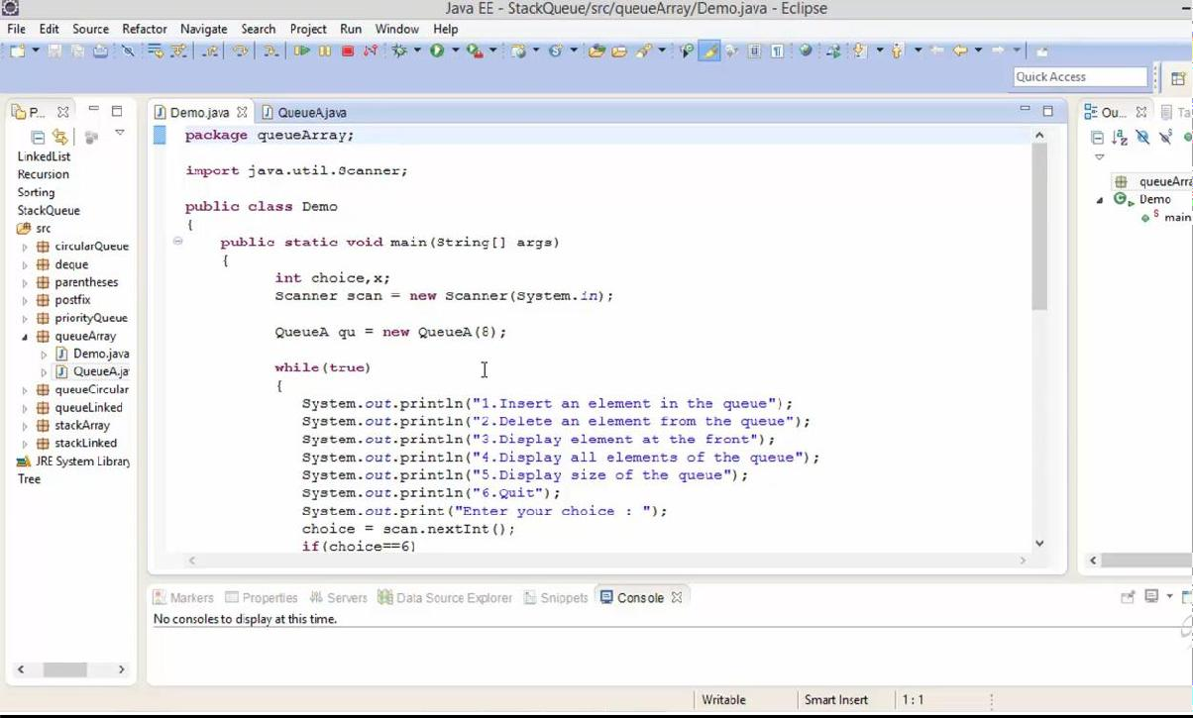

**STACK USING ARRAY**

import java.util.EmptyStackException;

public class StackA

{

private int[] stackArray; private int top;

public StackA()

{

stackArray = new int[10]; top = -1;

}

public StackA(int maxSize)

{

stackArray = new int[maxSize]; top = -1;

}

public int size()

{

return top+1;

}

public boolean isEmpty()

{

return (top==-1);

}

public boolean isFull()

{

return (top==stackArray.length-1);

}

public void push(int x)

{

if(isFull())

{

System.out.println("Stack Overflow"); return;

}

top=top+1; stackArray[top]=x;

}

public int pop()

{

int x; if(isEmpty())

{

System.out.println("Stack Underflow"); throw new EmptyStackException();

}

x=stackArray[top]; top=top-1;

return x;

}

public int peek()

{

if(isEmpty())

{

System.out.println("Stack Underflow"); throw new EmptyStackException();

}

return stackArray[top];

}

public void display()

{

int i;

if(isEmpty())

{

System.out.println("Stack is empty"); return;

}

System.out.println("Stack is : "); for(i=top; i>=0; i--)

System.out.println(stackArray[i] + " "); System.out.println();

}

}

Demo.java

import java.util.Scanner;

public class Demo

{

public static void main(String[] args)

{

int choice,x;

Scanner scan = new Scanner(System.in);

StackA st = new StackA(8);

while(true)

{

System.out.println("1.Push an element on the stack"); System.out.println("2.Pop an element from the stack");

System.out.println("3.Display the top element"); System.out.println("4.Display all stack elements"); System.out.println("5.Display size of the stack"); System.out.println("6.Quit"); System.out.println("Enter your choice : ");

choice = scan.nextInt();

if(choice==6)

break;

pushed : ");

st.peek());

switch(choice)

{

case 1 :

System.out.println("Enter the element to be

x=scan.nextInt(); st.push(x); break;

case 2:

x=st.pop();

System.out.println("Popped element is : " + x); break;

case 3:

System.out.println("Element at the top is : " +

break; case 4:

st.display(); break;

case 5:

System.out.println("Size of stack " + st.size()); break;

default:

System.out.println("Wrong choice");

}

System.out.println("");

}

scan.close();

}

}

STACK USING PYTHON

class EmptyStackError(Exception): pass

class Stack:

def init (self): self.items = []

def is_empty(self): return self.items == []

def size(self):

return len(self.items)

def push(self, item): self.items.append(item)

def pop(self):

if self.is_empty():

raise EmptyStackError("Stack is empty") return self.items.pop()

def peek(self):

if self.is_empty():

raise EmptyStackError("Stack is empty") return self.items[len(self.items)-1]

def display(self): print(self.items)

############################################## #############

if name == " main ": st = Stack()

while True: print("1.Push")

print("2.Pop")

print("3.Peek")

print("4.Size") print("5.Display") print("6.Quit")

choice = int(input("Enter your choice : "))

if choice == 1:

x=int(input("Enter the element to be pushed : ")) st.push(x)

elif choice == 2: x=st.pop()

print("Popped element is : " , x) elif choice == 3:

print("Element at the top is : " , st.peek()) elif choice == 4:

print("Size of stack " , st.size()) elif choice == 5:

st.display() elif choice == 6:

break; else:

print("Wrong choice") print()

# QUEUE USING ARRAY

import java.util.NoSuchElementException;

public class QueueA

{

private int[] queueArray; private int front;

private int rear;

public QueueA()

{

queueArray = new int[10]; front = -1;

rear = -1;

}

public QueueA(int maxSize)

{

queueArray = new int[maxSize]; front = -1;

rear = -1;

}

public boolean isEmpty()

{

return (front==-1 || front==rear+1);

}

public boolean isFull()

{

return (rear == queueArray.length - 1 );

}

public int size()

{

if(isEmpty())

return 0;

else

}

return rear-front+1;

public void insert(int x)

{

if(isFull())

{

System.out.println("Queue Overflow\n"); return;

}

if(front==-1)

front=0; rear=rear+1; queueArray[rear]=x;

}

public int Delete()

{

int x; if(isEmpty())

{

System.out.println("Queue Underflow"); throw new NoSuchElementException();

}

x=queueArray[front]; front=front+1; return x;

}

public int peek()

{

if(isEmpty())

{

System.out.println("Queue Underflow\n"); throw new NoSuchElementException();

}

return queueArray[front];

}

public void display()

{

int i;

if(isEmpty())

{

System.out.println("Queue is empty\n"); return;

}

System.out.println("Queue is :\n\n"); for(i=front; i<=rear; i++)

System.out.print(queueArray[i] + " ");

System.out.println();

}

}

Demo.java

import java.util.Scanner;

public class Demo

{

public static void main(String[] args)

{

int choice,x;

Scanner scan = new Scanner(System.in);

QueueA qu = new QueueA(8);

while(true)

{

queue");

System.out.println("1.Insert an element in the queue"); System.out.println("2.Delete an element from the

System.out.println("3.Display element at the front"); System.out.println("4.Display all elements of the queue"); System.out.println("5.Display size of the queue");

System.out.println("6.Quit"); System.out.print("Enter your choice : "); choice = scan.nextInt();

if(choice==6)

break;

switch(choice)

{

");

qu.peek());

case 1:

System.out.print("Enter the element to be inserted :

x = scan.nextInt(); qu.insert(x); break;

case 2:

x=qu.Delete();

System.out.println("Element deleted is : " + x); break;

case 3:

System.out.println("Element at the front is : " + break;

case 4:

qu.display(); break;

case 5:

System.out.println("Size of queue is " + qu.size()); break;

default:

System.out.println("Wrong choice");

}

System.out.println();

}

scan.close();

}

}

# QUEUE USING PYTHON

class EmptyQueueError(Exception): pass

class Queue:

def init (self): self.items = []

def is_empty(self): return self.items == []

def size(self):

return len(self.items)

def enqueue(self, item): self.items.append(item)

def dequeue(self):

if self.is_empty():

raise EmptyQueueError("Queue is Empty") return self.items.pop(0)

def peek(self):

if self.is_empty():

raise EmptyQueueError("Queue is Empty") return self.items[0]

def display(self): print(self.items)

############################################## #############

if name == " main ": qu = Queue()

while True: print("1.Enqueue") print("2.Dequeue") print("3.Peek")

print("4.Size") print("5.Display") print("6.Quit")

choice = int(input("Enter your choice : "))

if choice == 1:

x=int(input("Enter the element : ")) qu.enqueue(x)

elif choice == 2: x=qu.dequeue()

print("Element deleted from the queue is : " , x) elif choice == 3:

print("Element at the front end is " , qu.peek()) elif choice == 4:

print("Size of queue ", qu.size()) elif choice == 5:

qu.display() elif choice == 6:

break; else:

print("Wrong choice") print()

USING SIZE

class StackEmptyError(Exception): pass

class StackFullError(Exception): pass

class Stack:

def init (self,max_size=10): self.items = [None] * max_size self.count = 0

def size(self): return self.count

def is_empty(self): return self.count == 0

def is_full(self):

return self.count == len(self.items)

def push(self,x): if self.is_full():

raise StackFullError("Stack is full, can't push")

self.items[self.count] = x self.count+=1

def pop(self):

if self.is_empty():

raise StackEmptyError("Stack is empty, can't pop")

x = self.items[self.count-1] self.items[self.count-1] = None self.count-=1

return x

def peek(self):

if self.is_empty():

raise StackEmptyError("Stack is empty, can't peek")

return self.items[self.count-1]

def display(self):

print(self.items)

############################################## ############

if name == " main ":

st = Stack(8)

while True: print("1.Push")

print("2.Pop")

print("3.Peek")

print("4.Size") print("4.Display") print("6.Quit")

choice = int(input("Enter your choice : "))

if choice == 1:

x=int(input("Enter the element to be pushed : ")) st.push(x)

elif choice == 2: x=st.pop()

print("Popped element is : " , x) elif choice == 3:

print("Element at the top is : " , st.peek()) elif choice == 4:

print("Size of stack " , st.size()) elif choice == 5:

st.display() elif choice == 6:

break else:

print("Wrong choice") print()

USING SIZE

class EmptyQueueError(Exception): pass

class Queue:

def init (self): self.items = [] self.front = 0

def is_empty(self):

return self.front == len(self.items)

def size(self):

return len(self.items)-self.front

def enqueue(self, item): self.items.append(item)

def dequeue(self):

if self.is_empty():

raise EmptyQueueError("Queue is Empty")

x = self.items[self.front] self.items[self.front] = None self.front = self.front + 1 return x

def peek(self):

if self.is_empty():

raise EmptyQueueError("Queue is Empty")

return self.items[self.front]

def display(self): print(self.items)

############################################## #############

if name == " main ": qu = Queue()

while True: print("1.Enqueue") print("2.Dequeue") print("3.Peek")

print("4.Size") print("5.Display") print("6.Quit")

choice = int(input("Enter your choice : "))

if choice == 1:

x=int(input("Enter the element : ")) qu.enqueue(x)

elif choice == 2: x=qu.dequeue()

print("Element deleted from the queue is : " , x)

elif choice == 3:

print("Element at the front end is " , qu.peek()) elif choice == 4:

print("Size of queue ", qu.size()) elif choice == 5:

qu.display() elif choice == 6:

break; else:

print("Wrong choice") print()